**Algorithms and Flowcharts for Patterns.**

1. Pattern: Left triangle with number printed and times of repetition is same as the line number

1

22

333

4444

55555

**Algorithm:**

1. Declare n for number of lines and get input from user
2. Declare 2 looping variables i and j for outer and inner loop respectively, where i will only increment once a line is finished.
3. For outer loop, terminating condition is i<=n
4. For inner loop, terminating condition is j<=i
5. The inner loop will print the value of i.
6. Once inner loop exits, move to next line by a line break or next line character.

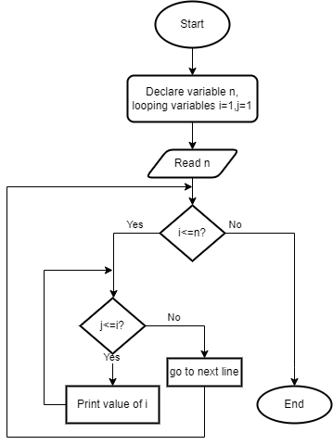

1. Pattern: Pyramid of asterisks

*

**

***

****

**Algorithm:**

1. Declare variables i, j, k, row, and spa.
2. Fetch number of rows into variable row from user.
3. Two nested loops, external loop with variable i and internal with variable j are to be run.
4. Check if i is less than rows or not
5. If yes, spa = k.
6. If k>1, print “ ” (empty space).
7. If not, then initialize j to 1.
8. Check if j > i.
9. If yes, print * (asterisk).
10. If no, then do spa.

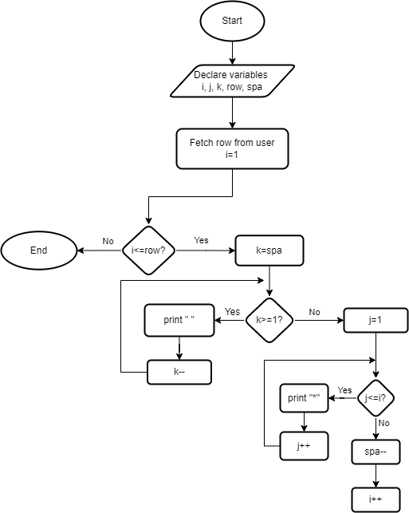

1. Pattern: Left triangle of number of digits same as number of line, max number = number of current line.

1

12

123

1234

**Algorithm:**

1. Declare variables i, j and num. i and j for external and internal loops, and n for number of lines.
2. Terminating condition for outer loop will be i<=num.
3. Terminating condition for inner loop will be j<=i.
4. The inner loop will print the value of j.
5. When the inner loop exits, move to next line by using next line character.

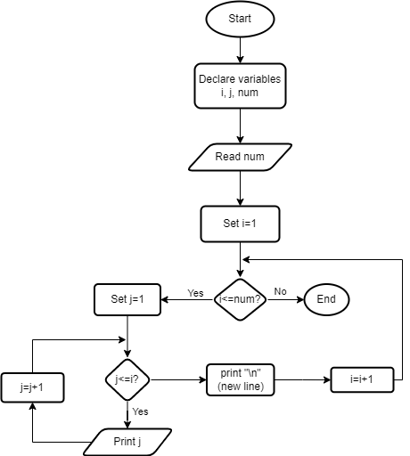

1. Pattern: Floyd’s triangle

1

2 3

4 5 6

7 8 9 10

**Algorithm:**

1. Declare and initialize looping variables, variables for number of rows, and numbers to print.
2. Get number of rows from user
3. Print the number in standard format using loops as follows:
   1. External loop runs for i to n
   2. Internal loop runs for j to i
   3. Print number inside the internal loop once and increment by 1
   4. Once internal loop exits, move to new line using new line character

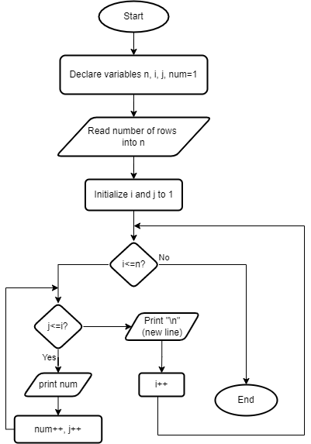

1. Pattern: Left Reverse Triangle with asterisk

*****

****

***

**

*

**Algorithm:**

1. Set up variables for 2 loops, number of rows; i, j and n
2. External loop termination condition will be i<=n
3. Internal loop termination condition will be j=i to j<=rows.
4. Print * in the internal loop
5. Once internal loop exits, go to next line using new line character.

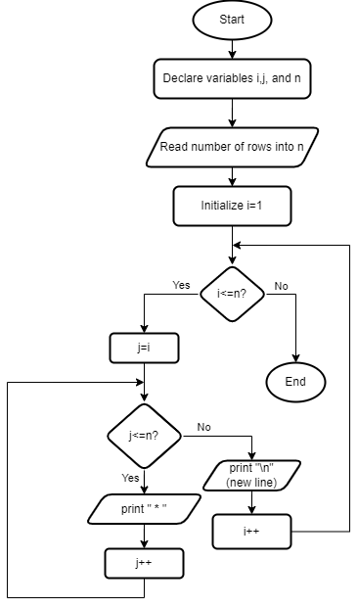

1. Pattern: square of hashes

####

####

####

####

**Algorithm:**

1. Declare the variables size, count and row, set value of row to 1
2. Check whether number of rows is less than size or not
3. Initialize col to 1 and then check if col is les than size or not.
4. If so, then print the hash symbol “#” and check count.
5. Then increment col and row respectively in loop.
6. End.

